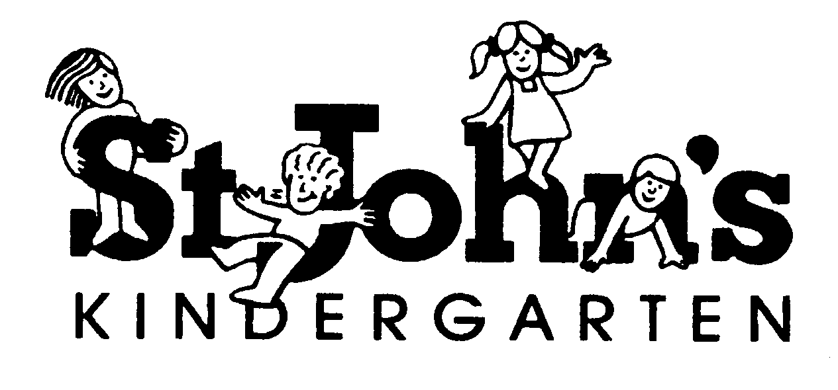

FAMILY INFORMATION BOOK

2026

We would like to welcome you and your child to St John’s Kindergarten.

We trust the year ahead will be enjoyable, interesting, and beneficial for all of our children and families. We are really looking forward to getting to know our new families and reacquainting ourselves with the old!

St Johns Kindergarten offers three groups of 4-year-old funded kindergarten program, each attending 15 hours per week. Bunjil attend Wednesday and Thursday, Waa attend Thursday and Friday and Muk Muk attend Wednesday and Friday, all 8:30am – 4:00pm sessions.

We also offer a 3-year-old funded kindergarten group of 15 hours per week. The Balam Balam group attends Monday and Tuesdays 8:30am to 4:00pm.

Our aim is to monitor and extend your child in all areas of their whole development. This includes, but is not limited to, developing positive social/emotional skills, physical, language/communication skills, strong wellbeing and identity, and develop an appreciation for learning and their community.

The program is planned to use both indoors and outdoors effectively in order too scaffold children’s learning needs, interests, and skill set. Our service embeds the ACECQA (Australian Children Education and Care Quality Authority) National Quality Framework in all the educational programming and practice documentation processes.

As the year progresses and the children’s skills and attitudes develop, the educational learning program changes to offer further challenges and interests.

STAFF

Director/Educational Leader:

Bec Vernall: Early Childhood Teacher

Balam Balam:
Teacher (Early Childhood Teacher) – Katrina
Activity Leader (Diploma) – Anna
Educator (Cert III) – Davina
Educator (Cert III) – Laura

4 – year – old groups – Bunjil, Waa and Muk Muk
Wednesday:
Teacher (Early Childhood Teacher) – Jodie
Activity Leader (Diploma) – Stacey
Educator (Cert III) – BJ
Educator (Cert III) – Laura

Thursday and Friday:
Teacher (Early Childhood Teacher) – Jodie
Activity Leader (Diploma) – Stacey
Educator (Cert III) – BJ
Educator (Cert III) – Terry

Casual Educators:

Maisie: Working towards Early Childhood Teacher

Lana: Working towards Early Childhood Teacher

Administration Officer:

Mel Shea – 8:30am – 2:30pm Tuesday, Wednesday and Thursday

CONTACT DETAILS

KINDERGARTEN: 9723 4119

Email: st.johns.croydon.kin@kindergarten.vic.gov.au

Web address: www.stjohnskindergartencroydon.org.au

DEPARTMENT OF EDUCATION & 1300 333 231

TRAINING (North Eastern Region)

Email: nevr@education.vic.gov.au

ACECQA: 1300 422 327

Email: enquires@acecqa.gov.au

ANY CONCERNS

If you are unhappy about any aspects of the kindergarten our Centre has a complaint and grievance policy located in the entrance area which outlines the processes for complainants. Please direct your concerns firstly to your Teacher for resolution, if this does not result in an amicable outcome please scaffold it to the Director. A resolution meeting will be organised to discuss the issue. Please refer to the above Complaints and Grievance Policy, located in the front entry information display board for more detailed information.

SESSION TIMES

Balam Balam 3-year-old  Monday 8:30am – 4:00pm  Tuesday 8:30am – 4:00pm | Bunjil 4-year-old  Wednesday 8:30am – 4:00pm  Thursday 8:30am – 4:00pm
Waa 4-year-old  Thursday 8:30am – 4:00pm  Friday 8:30am – 4:00pm | Muk Muk 4-year-old  Wednesday 8:30am – 4:00pm  Friday 8:30am – 4:00pm

TERM DATES FOR 2026

Term 1: Tuesday 27th January – Thursday 2nd April

Term 2: Monday 20th April- Friday 26th June

Term 3: Monday 13th July – Friday 18th September

Term 4: Monday 5th October – Friday 18th December

In consultation with the Department of Education and Training, the Australian Education Union and the St John’s Kindergarten Committee of Management there are 4 student free curriculum days in 2026.

PUBLIC HOLIDAYS 2026 (Kinder closed)

Labour Day – Monday 9th March

Easter – Friday 3rd April – Monday 6th April

ANZAC Day – Saturday 25th April

King’s Birthday – Monday 8th June

Grand Final Public Holiday – subject to schedule

Melbourne Cup Day –Tuesday 3rd November

St John’s Philosophy

Vision

To provide high quality education for all children in a safe, nurturing and stimulating environment where young children can explore, play, learn and grow whilst our early learning environment recognises of the importance of early childhood education in setting a child up for lifelong learning.

Philosophy

At St. John’s Kindergarten we prioritise the well-being and holistic development of the children in our care, in an all-inclusive, supportive, and engaging learning environment that fosters curiosity, creativity, and a love of learning.

We recognise each individual child and their unique developmental needs and nurture this while delivering enjoyable learning experiences that enable and empower children to reach their full potential.

We maintain a collaborative culture of reflection to actively address the needs of our diverse community, inclusive of First Nations peoples within our local and wider community. Our commitment to evolving contemporary practices, centred on the rights of children, families, educators, and the wider community, helps create an open and supportive environment.

Our kindergarten’s educational program is firmly grounded in the Victorian Early Years Learning Development Framework (VEYLDF) and the Child Safe Standards. We are committed to the highest standards by seeking to incorporate evolving educational theories and current research within the early childhood field. We strive to consistently meet and exceed these standards, ensuring the best possible learning experiences for our young children.

ARRIVAL AND DEPARTURE OF CHILDREN

Procedure:

Children must be brought into the kindergarten playroom by their parent or caregiver.

The accompanying adult must sign in via the ipad with the exact time of arrival.

All sessions begin with the children entering the building, hanging up their bags and placing lunch box, snack box and drink bottle in their lockers.

Staff are required to check the Arrivals system during the session and ensure that all children in attendance have been signed in and time of arrival recorded.

The teaching staff must be informed if someone different has been authorised to pick up the child. This authorisation should be in writing by the parent /guardian, authorisation forms available upon request.

The accompanying adult must note down the exact departure time in the Arrivals system before the child leaves the kindergarten premises.

Children are not permitted to leave the service until a staff member releases them into the supervision of their parent /caregiver who is in the building, at which point responsibility for the child rests with the parent/caregiver.

Staff are required to check Arrivals at the completion of the session to ensure all children have been signed out and time of departure recorded.

Parents who are continually late in picking up children will be given a verbal warning followed by a written notification from the Committee. If late pick up continues, a charge of $5.00 per minute will be imposed from five minutes after the end of the session time.

Medical Conditions Information

If your child has a medical condition such as Asthma, Anaphylaxis or Allergy, please download, print and fully complete, with doctor’s signature, the aforementioned forms. We are governed by the National Early Childhood Education and Care Law and Regulations to have these medial documents fully completed and Doctor signed kept on the premises with your child’s enrolment forms. Additionally, we have individual medical bags, with parent provided medication, currently located in the classroom for easy access in case of need and emergency evacuation purposes. Please find links below to access information regarding these documents: MUST BE A COLOUR COPY!

http://www.allergy.org.au/hp/anaphylaxis/ascia-action-plan-for-anaphylaxis

https://d8z57tiamduo7.cloudfront.net/resources/341-NAC-Asthma-Action-Plan-2015_Writeable.pdf

https://www.allergy.org.au/hp/ascia-plans-action-and-treatment#r2a

BEHAVIOUR MANAGEMENT

The children are to know that kindergarten is a place where all have the right to feel safe physically and emotionally. Staff will take preventative measures and or redirect unacceptable behaviour. All possible avenues of assistance will be taken to maintain a safe environment. Teachers in collaboration with parents and Committee will organiase extra assistance from other agencies, visiting teachers, aides or volunteers as necessary.

No child will be subject to any form of corporal punishment, immobilization or any other humiliating or frightening techniques. At St John’s Kindergarten we aim to develop independence and responsibility, as well as cooperation with others and good self esteem:

We constantly reinforce acceptable behaviour by praising children and recognising their attempts to be helpful.

We identify why the behaviour is not acceptable, and discourage hitting, kicking, biting etc, by helping children learn more acceptable ways of expressing their feelings, eg through the use of language.

We try to anticipate and redirect inappropriate behaviour.

We do not isolate children away from their peers or adults.

We do not ‘speak down’ to children.

BIRTHDAYS

A birthday is a special event! We would love to help celebrate your child’s birthday, so feel free to send along something special the children can share with their peers to take home. For example, fidget toys, small chocolate such as a freddo frog, lollipop etc. We send these home with the children at the end of the day after singing happy birthday.

Please remember NO NUT PRODUCTS – INCLUDING NO NUTELLA PRODUCTS.

CHILDREN’S HEALTH AND SAFETY

Health: Please inform the staff if your child is ill or will be absent from kindergarten. The best time is before the session commences 8:00am – 8:30am pr you can email your teacher. If your child is feeling overtired, heat exhausted, has a temperature or is just ‘off color’, please keep your child at home where they can recover. If your child presents with any cold or flu-like symptoms, this is also concern to keep them at home until their symptoms clear. Kindergarten isn’t fun if you are unwell. If your child is not well enough to go outside, they are not well enough to come to kinder.

If in doubt – DON’T!


Incident/ Injury/ Trauma and Illness: All care is taken and supervision of children inside and out is constant, however the occasional accident happens. If this is the case, the child is comforted, first aid procedures followed, the parent is contacted if necessary and staff complete an Incident Record which the parent will sign on arrival at kinder to acknowledge the incident. This is also the process if a child suffers from a serious illness or trauma.

Qualified First Aiders Are Always Present!

CLOTHING

The children need comfortable and practical clothing which allows them to get dirty and which allows freedom of movement. Therefore, we discourage the wearing of dresses as it inhibits the children’s outdoor movement and in fact can be extremely dangerous when climbing. Sturdy shoes or sandals are best. NO THONGS OR CROCS OR BALLET FLATS as feet slip out of them and they are not safe. Please remember a coat and warm hat in the cold months.

As we are a “Sun Smart Kindergarten”, wearing a hat that is wide brimmed is compulsory when UV is 3 and above. In addition to these procedures on a daily basis. Staff check the SunSmart app UV rating, any UV rating over 3 requires sun protection i.e., hats and sunscreen. Children without a hat will not be permitted to play outside. Please note that the kindergarten supplies hats at the start of the year.

When UV is to reach 3 and above early in the morning, we will place the sunscreen out the front for children to apply before the session starts. Children are encouraged to have a hat that is specifically for kinder. Clearly mark your child’s name on it and leave it in their kinder bag. Your child will then always be sun smart at kinder, collecting their own hat on the way outside.

Please remember to put several spare change of clothes for your child in their kinder bag. Accidents do happen - getting wet in the sandpit or not making it to the toilet in time is a frequent occurrence.

****Note: please name all items of clothing and keep up to date with the weather and your child’s changing size.

COMMITTEE OF MANAGEMENT

The Committee of Management is a legally constituted body who administers and managers St John’s Kindergarten. The committee is responsible for the daily management of finance, correspondence, maintenance and social events. The Committee comprises parents who perform the roles of President, Vice President, Secretary, Treasurer, Maintenance Officer, Social Committee and general committee members. The Committee therefore has a very important role within the operation of the kindergarten. Monthly meetings help keep committee members up to date with the educational program, the budget, maintenance requirements, social occasions and so on.

DEPARTMENT OF EDUCATION

The Department of Education & Training regulates the overall requirements and conditions of the Centre. The kindergarten is inspected on a regular basis to ensure that we comply with the children’s services regulations.

The Department also provides funding for each child in our funded kindergarten program with a per capita subsidy which contributes to a portion of staff wages, the balance of running expenses being met through the “free Kinder” subsidy.

EARLY YEARS FRAMEWORK

The Early Years Learning Framework provides the foundation of our play-based curriculum. The Framework is a document that supports the program and planning of preschools and childcare nationwide. The Framework foster’s development of the whole child, in the following areas:

Identity: the child’s sense of identity

Community: the child’s connection with and contribution to their world

Wellbeing: the child’s sense of wellbeing

Learning: the child’s confidence and involvement in learning

Communication: the child’s communication skills

Interests: each individual child’s interests are noticed & developed

EMERGENCY PROCEDURES

All emergency procedures are discussed and practiced each term with children. For fire and other disaster plans please refer to the Emergency Management Plan and the Evacuation Plan on the wall in the kindergarten. Generally, the evacuation point is at the far end of the car park.



EXCURSIONS/INCURSIONS

During the year we plan several incursions which we consider to be relevant and worthwhile. The kindergarten groups participate in more of these than the prekindergarten groups. We attempt to keep the extra cost to a minimum and try to balance the types of experiences.

All children must have parents’/guardians’ permission prior to leaving the Centre on an excursion. We have a regular outing form that is signed at the beginning of the year to venture into the immediate community surroundings of Kindergarten.

We also invite special visitors into the kindergarten to supplement the program such as Police Officers, Nurses, Dentists etc.

On some occasions, special events, for example incursions/excursions may require a small fee to cover costs, details of which will be included in your fee notice.
FAMILY PARTICIPATION

We would like to encourage family participation across all aspects of our program. We warmly welcome parents, grandparents, aunts, uncles and friends to drop in for a visit anytime. We value ideas and contributions from families, and part of our aim is to make your family feel welcome and comfortable at kinder.

Ideas or suggestions are most welcome at any time. Also, we would be interested in hearing from you if you have any “special talents” you may wish to share with us, such as playing the guitar, singing, cooking etc.

FREE KINDERGARTEN

No fees are required from families due to the government and department subsidies that are funding free Kindergarten for all children.

INFECTIOUS DISEASES

Please refer to the Infectious Diseases exclusion table via the link below.

https://www2.health.vic.gov.au/public-health/infectious-diseases/school-exclusion

IMMUNISATION STATUS

As part of the Government No Jab No Play program it is a Departmental requirement that we have a current copy of your child’s Immunisation status on file. This Immunisation Statement can be accessed through your MyGOV account.

INTERVIEWS & TRANSITION STATEMENTS

Interviews are held at the start of the year and we welcome you to continue this learning partnership. Feel free to approach us at any time about your child’s progress or development. Please contact your teacher to organise a suitable time to discuss. In November you will receive your child’s Transition Learning and Development Statement, that will be sent online to your child primary School. You will also receive a copy of this Statement. This Statement gives an overview of your child’s learning and development. It will provide strategies for their prep teacher to assist in a smooth transition to school.
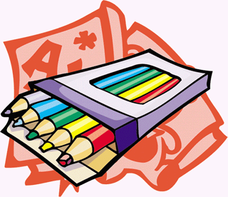

LOCKERS/PEGS

Each child will be allocated their own locker in which they place their snack and drink bottles. Please check each session for artwork and personal belongings. Do not expect that your child will have artwork to bring home every session.

Your child will also have a peg in the bag room to hang up bags and coats.

NATIONAL QUALITY FRAMEWORK

The National Quality Framework is the result of an agreement between all Australian governments to work together to provide better educational and developmental outcomes for children using education and care services. As the NQF progresses every service in the country will be assessed to make sure it meets the standard. A part of this process involves our centre evaluating all our practices, policies, educational program and environment and writing a Quality Improvement Plan. This is to ensure we are consistently assessing and reflecting on all we offer and do.

In March 2025, St John’s Kindergarten had its’ NQF accreditation assessment inspection.

We are pleased to report we received the following ratings:

Quality Area 1 | Education Program and Practice | EXCEEDING
Quality Area 2 | Children's Health & Safety | EXCEEDING
Quality Area 3 | Physical Environment | EXCEEDING
Quality Area 4 | Staffing Arrangements | EXCEEDING
Quality Area 5 | Relationships With Children | EXCEEDING
Quality Area 6 | Collaborative Partnerships with Families & Communities | EXCEEDING
Quality Area 7 | Leadership & Service Management | EXCEEDING

NEWSLETTERS & NOTICES

Newsletters and notifications with be sent to you via Storypark. It is important to keep track of all notifications, so you do not miss out on important and relevant information.

ORIENTATION PROCEDURE

Orientation is conducted in the year prior to your child starting at St John’s. The date and time will be emailed for when you and your child will attend. The purpose of orientation is to allow each child to adjust to a new environment and new adults in a relaxed manner. This is often done in smaller groups with shorter sessions.

Some children may adjust and be happy from the minute they walk through the door, whilst others take a little more time. Staff are trained to deal sensitively with any tears that may follow. We encourage you to phone the kinder later if your child is unsettled when you leave. If your child hasn’t settled after a prolonged period of time, staff will contact you.

In conjunction with the enrolment form, a “All About Me” form is provided for you to fill in any information that you feel may be helpful to the care of your child. The more we know about your child’s likes/dislikes, habits, routines etc, the easier it is for us to get to know your child, therefore, easier to settle in.

PERSONAL DETAILS

Please advise your child’s teacher if something has happened at home which could be affecting your child’s behavior, e.g. change in family circumstances, death of a family member, or pet etc. Please advise staff in writing of any change in address, phone number or email.

POLICIES

St John’s Kindergarten has implemented the following policies under the Education & Care Services National Regulations and National Law Act 2010. These incorporate the Standards & Regulations of the National Quality Framework. St John’s Kindergarten has adopted these policies and amended them as required in consultations with staff and committee.

A full copy of all policies and procedures are available for viewing by our kinder families. Please speak to staff if you wish to read them.

SAFETY

Please remember to close the gates behind you each time you leave the kindergarten. Also be aware of other children following you as you leave.

Please do not allow children to climb or swing on the gate as damage to the gate may comprise its ability to close securely.

Please hold your child’s hand at all times in the car park.

Please drive slowly and cautiously while you are in the car park.

SESSION ROUTINE

All sessions start with the children coming in, hanging up their bags and coats, popping away their snacks in their lockers and washing their hands. The 3-year-old Balam Balam Group then explore the indoor and outdoor environment, while the Waa, Bunjil and Muk Muk Groups come down to the mat with their teachers and friends to spend a little time socialising and playing with construction and manipulative equipment.

We then have short whole group activities which provide a range of learning experiences such as various discussions, creative drama and movement, singing, musical instrument playing, science experiments or perhaps a story before moving off to an inside activity.

At the end of each session the children are encouraged to help clean up and pack away equipment before we finish off with chat, story, song or rhyme and generally looking ahead to the next time we are altogether. Families enter through the outdoor entrance and exit through the front door once their child has been collected. Please wait for your teacher to say goodbye to the children so we can ensure all children leave with their correct adult.

SIGNING IN AND OUT

Please sign your child in and out via the Arrivals system on the ipad provided upon your arrival at kinder.

This is a legal requirement!

SNACK

At St John’s Kindergarten we have an informal snack time which helps to develop the childrens’ autonomy and independence. This involves the children deciding when to suspend their play and have a snack at our eating table. We encourage LITTER FREE SNACKS. The children must first wash their hands, collect their snacks out of their lockers, find a spare seat at the table and remain seated while they are eating. We encourage a variety of nutritious foods that promote sustained energy.

fresh, tinned or dried fruit

vegetables

sandwiches

yoghurt

biscuits

protein

a drink - water only

Be mindful of sending meat and yoghurt in the hot weather – pop in a cold pack in your child’s lunch bag.

PLEASE DO NOT SEND

ANY NUTS OR NUT PRODUCTS (e.g. Peanut butter, Nutella)

Lollies

ST JOHN’S IS AN ALLERGY AWARE KINDERGARTEN.

NO NUTS IN ANY FORM!

SOCIAL/FUNDRAISING ACTIVITIES

We provide a variety of social and fundraising activities throughout the year. We understand families may also have fundraising obligations with older children at school, however we encourage you to participate in as many as you can with kinder. The social committee plans one major event for the year and various smaller activities such as morning teas, trivia night, movie nights etc.

At the end of each year we have our annual Christmas breakup at Mooroolbark Miniature Railway. We look forward to celebrating the end of the very happy and successful year with our wonderful kindergarten community.

We hope you and your family can come along and participate in the fun activities organised by our social committee. The social activities provide a great opportunity for all our families to meet one another.

STAFF

In line with ACEQEA National Quality Framework child to staff ratio of 1 Educator to 11 Children, each group has a teacher and an educator in each session. In certain situations an additional assistant maybe provided by the Uniting Kindergarten Inclusion Support program, funded by the Department of Education and Training.

All staff are first aid trained and have additional training in asthma management and anaphylaxis management. All staff employed must have a current Working with Children Check OR VIT.



STUDENTS AND VOLUNTEERS

St John’s Kindergarten is committed to its work in the local community.

Thru out the year, you will see students from local schools undertaking work experience or volunteer service. We also have students from universities undertaking placement.

We require that all the students and volunteers hold a current working with children’s check and have signed our code of conduct policy.

TECHNOLOGY @ KINDER

At our service we have numerous iPads and a 32inch screen that the staff use in their documentation program planning. We use the online documentation platform Storypark to document daily individual and group learning activities and experiences. Throughout the day we use these tools to answer many of the children’s questions. Some questions we don’t know the answer to or would be better explained to the children using visual support. By using the iPad we will be able to support and extend the children’s knowledge and understanding in small group situations.

During whole group discussions we will use the larger monitor to share the information with all the children. If discussing dinosaurs it will be great to show the children real images and short clips of dinosaurs. When doing music it will be great to listen to and watch real musical instruments being played.

The iPad is an educational resource and will not be used to play games on or for the children to operate for extended periods of time. The screen will be used for sharing information with the larger group and will not be used for TV shows or movies for the children.

THINGS TO BRING TO KINDERGARTEN

a kinder bag that is easily opened and practical for your child to manage, big enough to fit in a hat, snack and change of clothes, and to take home uncrushed pieces of artwork.

Snack and lunch box

Several changes of clothes in case of accidents

Sunscreen if your child provides special sunscreen

Drink bottle with water only

Please do not allow your child to bring toys from home as they tend to get lost or broken and are often not appropriate. The same applies to jewelry!

UNIFORM

Uniforms such as t-shirts, windcheaters, zip-up hoodies and hats are available to purchase via Eduthreads, information is included in your enrolment pack.

www.eduthreads.com.au

WEBSITE

Website address: www.stjohnskindergartencroydon.org.au



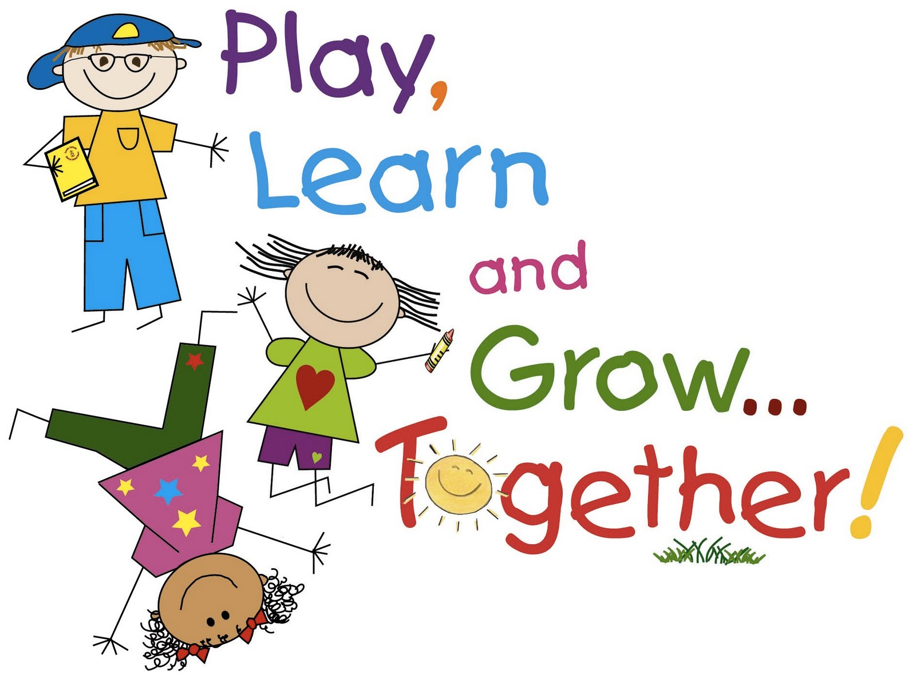

A LAST WORD…..

Thank you for choosing St John’s Kindergarten in the education and care of your beloved child. We are looking forward to sharing a productive, rewarding and enjoyable year as we nurture and help them in their whole development. It will be a year of social learning where children learn to play with others as well as develop confidence, strong identity in themselves and as part of the community and learning to collaborate in their early learning environment.

We want our kindergarten to be a very happy place for your child and a place where you can feel confident in leaving them. We invite and welcome a collaborative partnership with the family, please let us know in anyway how we can develop and support your child’s learning experience at St John’s Kindergarten.

We look forward to a very happy and enjoyable 2026 year with you all.

Kind regards,

St John’s team!

